***EC 204 Empirical Economics II - Tuesday and Thursday 12:30 pm, Fall 2018***

***Professor Stacey Gelsheimer***

***Group 8: Fernanda Gutierrez and Tegveer Ghura***

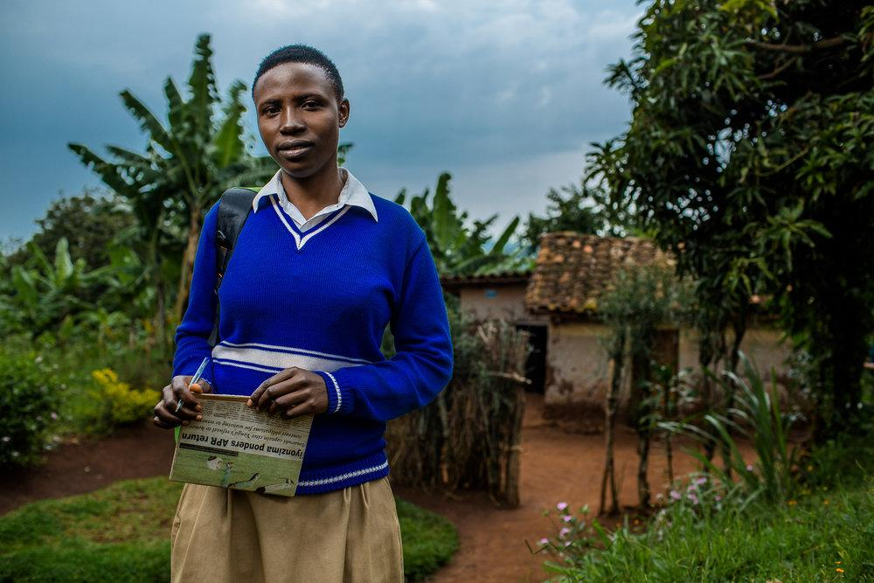

***http://www.namuh.org/stories/keeping-girls-in-school***

***“What is the effect of Education on Ideal Number of Children? “***

*A study about Botswana, a country with the lowest fertility rate in Sub-Saharan Africa and where women are more educated than men (WorldBank,2010).*

**Abstract:** Extensive research has proven the impact of Botswana’s family planning, the strongest in Africa, on fertility rate; consequently, the effect of education is equivocally overlooked and a more unique independent variable, “Ideal number of children”, is rarely the focus of studies. Using data from the 1988 Demographic and Health Survey and regression analysis, we examine this persistent, powerful negative relationship, whose effects on reproductive mentality surpass those of contraceptive knowledge. The significant impacts of age at first birth, children death, television access, and urbanization on ideal number of children are also analyzed and used for the proposition of policy solutions.

**Introduction**: Botswana’s education, free until 2006, made it one of the few countries, where women are more educated than men (WorldBank, 2010). From 1981 to 1988, school enrollment arised from 4.4 to 5.4 years of schooling, a large increase even considering the period’s rapid socioeconomic change (Thomas, Muvandi, 1992); at the same time, the fertility rate dramatically dropped from 7.1 to 5 children. Through this research, we intend to analyze this correlation, using, however, ideal number of children as the independent variable instead of simply number of children, allowing us to assess whether there was a real change in reproductive mindset, which is rarely captured by fertility decline and contraceptive use. Tackling ideal number of children becomes even more meaningful, when considering Martin’s argument (later on discussed under Literature Review), in which countries where desired family size surpasses fertility rates (which is the case of Botswanna as we can see in the means on Table 1), sustained fertility reduction can’t be achieved only through reproductive goals, but a transformation of reproductive norms and mentalities, indicated through variables such as idlnchdl, as well as socioeconomic conditions that hinder the demand for many children, such as the capitalist lifestyle and opportunity costs provided through education, as claimed by Basu.

Therefore, we aim to infer the effect of a woman’s years of education on her ideal number of children, which we expect to be a linear, negative relationship between the variables, in which more years of schooling would be associated with a decrease in ideal number of children. By introducing explanatory variables, correlated to both our dependent and independent variables of interest, we expect to control for negative and positive omitted variable bias and that the coefficient of education will, therefore, decrease, but maintain significant. We also expect that the dummies, living in an urban area and knowledge about contraceptive methods will have negative, significant slopes, meaning that women who are informed about family planning and those who live in urban areas and are more susceptible to capitalist institutions, relations, and aspirations that require smaller family sizes would have statistically different and lower means of ideal number of children than those who do not. We also expect husband education to have either a negative or positive coefficient, as such variable could influence both a labor-market-induced low fertility desires through the father or account for more income, which could lead to an increased idlnchld. Furthermore, we believe that age and age at first birth could have nonlinear trends, once the sample accounts for women from 15 to 49 years old and, therefore, observations plotted in the beginning of scatter plots would be have higher values for idlnchld due to Botswana’s issue on teenage pregnancy, and slowly fall as age increases.

After examining the data through regression analysis, we were able to conclude that years of education have a consistent, negative, and extremely significant impact on idlnchld, even after controlling for all the other variables. Other factors that remained significant until the last Model (12), portrayed possibly efficient ways for policy makers to target the ideal number of children among women in Botswana, especially if further implemented in non urban areas : increasing or redirecting funds from secondary to primary education and investing in Television broadcasting geared toward education on societal issues, such as early childbearing trends, children mortality, and women empowerment through schooling.

**Literature review**: Since its independence in 1966, Botswana has had a stable government and economic growth, being listed the only African country among the 13 “economic miracles” of the world for 1960–2005. Additionally, its national family planning program, a product of a strongly commited government, has contributed for the greatest fertility decline in Sub-Saharan Africa is a remarkable step for women care, especially in a country where women outnumber men, both demographically and educationally (WorldBank, 2010). Throughout time, scholars have tried to understand tremendous exceptionality, often linking it not only to outspread and free family planning, but also to schooling. For instance, according to Gaisie, Botswanna’s relationship between education and fertility is primarily associated to colonialism and the introduction of new capitalist institutions, embodied, most importantly, by the impact of labor migration and its consequent prologued father absence, change in sexual behaviors and delay of marriage to a much later age. Highly educated women became less willing to accept polygyny as well as to prefer relationships with men with the same or higher education level or wealth (Gaisie,1995). Basu, however, adresses to more specific aspects of education, such as its effect on gender equality, that is, women’s autonomy to make and act upon decisions, including the control over resources, their mobility, and interaction with the world, which would reflect on reproductive decision-making and autonomy. Furthermore, she argues that education lowers fertility and ideal number of children through increasing aspirations, especially materialistic, and through new external opportunities, for instance in the labor market, which naturally require a smaller family size (Basu, 2002). Martin adds that in countries, where the desirable family size is below fertility rates, the implementation of family planning programs would lead to a decline; however, in countries where the size is superior, more complex social and reproductive norms that underlie such demand must be confronted and adressed.Hypothesis about cases uncorrelated to education are also explored, for instance, by Rutenberg and Diamond, who believe Botswana’s fertility decline was actually caused by a major drought that occurred in the early 1980s and which caused extreme economic hardship, especially in rural areas, migration to urban cities, reduced sexual intercourse, separation of partners, and so on, creating the perfect environment, where delayed pregnancy encountered an increasingly successful family planning program.

**Data description**: Our data set, FERTIL2.RAW, offered by the Wooldridge Textbook, is a sample from Botswana’s 1988 Demographic and Health Survey taken by James Heakins. There are, in total, 4361 observations, which represent each woman interviewed in 1988, charaterizing the data as cross-sectional.

**Table 1: Variable Descriptions**

|  |  |  |
| --- | --- | --- |
| **Variable Name** | **Labels** | **Description** |
| Ideal number of children | idlnchld | Ideal number of children desired per woman |
| Education | educ | Woman’s education measured in years |
| Age | age | Woman’s age measured in years |
| Radio | radio | = 1 if the woman owns a radio  = 0 if the woman does not own a radio |
| Tv | tv | = 1 if the woman owns a TV  = 0 if the woman does not own a TV |
| Children ever born | ceb | Number of children ever born per woman |
| Number of living children | children | Number of children still alive per woman |
| Know about contraceptive methods | knowmeth | =1 if knows about contraceptive methods  =0 if does not know about contraceptive methods |
| Husband's years of education | heduc | Husband’s education measured in years |
| Age squared | agesq | Woman’s age measured in years squared |
| Living in an urban area | urban | =1 if woman lives in urban area  =0 if woman does not live in urban area |
| urban*education | urbeduc | Interaction Term between woman’s education in years and if they live in an urban area (=1 if urban). |
| Death of Children | chdth | Variable we have generated by subtracting number of living children from children ever born per woman ( ceb - children) in order to infer about child mortality within the family and how it affects ideal number of children per woman. |
| Age at First Birth | agfbrth | Woman’s age in years at first child’s birth |
| Age at First Birth Squared | agfbrthsq | Woman’s age in years at first child’s birth squared |

* Botswana’s 1988 Demographic and Health Survey

** One observation per woman

***Wooldridge Textbook

**Table 2: Summary Statistics**

--------------------------------------------------------------------------------------------

(1)

--------------------------------------------------------------------------------------------

Ideal number of children 4.616

idlnchld (2.219)

Years of education 5.856

educ (3.927)

=1 if live in urban 0.517

urban (0.500)

Interaction Term 3.469

urb_educ (4.294)

Age in years 27.41

age (8.685)

Age in years squared 826.5

agesq (526.9)

Husband's years of education 5.145

heduc (4.803)

=1 if know about contraceptive methods 0.963

knowmeth (0.188)

=1 if has tv 0.0929

tv (0.290)

=1 if has radio 0.702

radio (0.458)

Number of dead children 0.174

chdth (0.511)

Age at first birth 19.01

agefbrth (3.092)

Age at first birth squared 371.0

agefbrthsq (131.3)

Children ever born 2.442

ceb (2.407)

Number of living children 2.268

children (2.222)

-----------------------------------------------------------------------------------------------

N 4361

-----------------------------------------------------------------------------------------------

mean coefficients; sd in parentheses

* Botswana’s 1988 Demographic and Health Survey

** One observation per woman

***Wooldridge Textbook

**Model Section**

$${idlnchld}_{i}=β_{0}+β_{1}{educ}_{i}+β_{2}{urban}_{i}+β_{3 }urb{educ}_{i}+β_{4 }{age}_{i}+β_{5 }{agesq}_{i}+β_{6 }{heduc}_{i}+β_{7 }{knowmeth}_{i}+β_{8 }{radio}_{i} + β_{9 }{tv}_{i}{+ β_{10 }{agefbrth}_{i} + β_{11 }{agefbrthsq}_{i}+β_{12 }{chdth}_{i}+ u}_{i}$$

Our model estimates the partial effect of a woman’s years of education on the continuous variable “ideal number of children”, holding constant other relevant explanatory variables. We believe $β_{1}$ will be negative, once education would allow for greater reproductive autonomy and decision-making as well as a greater acceptance of contraceptive methods (and questioning of social norms or trends, such as early sexual intercourse). Furthermore, besides incorporating school conduct, such as discipline and self-constraint, more years of education would provide more labor opportunities and aspirations for social mobility (and, therefore, a higher opportunity cost for having a child).

By including the dummy urban, we expect a negative $β_{2}$, showing that women in such areas have lower idlnchld than women in rural regions. Developed and modernized areas, provide better education, besides lifestyles and mindsets, which fit capitalist structures and opportunities, placing a high opportunity cost on children and disconnecting from old traditions of high fertility (negative o.v.b.).We also control this variable, because it can easily affect the coefficients of many other explanatory variables if not omitted. Furthermore, we introduce an interaction term, in order to analyze if the relationship between education and ideal number of children depends on woman living in the urban area or not and we expect $β_{3 }$ to be significant.

We include age expecting that $β_{4 }$ is positive and that we are controlling for negative o.v.b. ; as age goes up in such cross-sectional data, we expect that women from an older generation have a higher ideal number of children and lower levels of education, due to the country’s past underdevelopment and cultural traditions. We then add its quadratic term, age squared, once we suspect non-linearity: we believe that $β_{5 }$ will be negative and significant, that is, for younger women in this survey, additional years of education would be more impactful on their ideal number of children than for older women, who may not be involved in school anymore by that time or may have already had their ideal no. of children. That is also because the sample has a min for age of 15 years old, which is a period where women are more involved with primary schooling, and therefore, the youngest observations might have the highest education.

We control for Husband’s years of education, expecting either a positive or negative $β_{6 }$,once the husband can be equally affected by more opportunities with a greater formation as well as by a higher income, which could have a negative or positive relationship with ideal number of children respectively. Also, by having a higher status husband, a woman could be tempted in dropping off primary or secondary education. Therefore, both negative and omitted variable bias can exist and be controlled for.

By adding dummy knometh, we expect it to have a significant, negative $β_{7 }$, showing that the mean ideal number of children is statistically different for women who know(and smaller) and who do not know about contraceptive methods.By controlling for knowmeth, we intend to infer about the effect of education itself and not, family planning programs.

The dummies radio and tv are also added as we expect them to have negative and significant $β_{8 }$ and $β_{9 },$ meaning that women, who own such devices, have lower and statistically different ideal numbers of children compared to those who do not have access to it. Controlling for mass media makes sense, once important information about family planning and deseases, such as the governmental national AIDS education campaign were often broadcasted, for instance in Radio Botswana (Zaffiro, 1993). Tv is also an important vehicle to convey social responsibility messages and modern ideologies.Because tv and radio control for similar things, we place them under the same concept umbrella of “Mass Media” and will run a joint hypothesis test, whose p-value, we believe to be significant.

We introduce age at first birth to the model because childbearing, especially in Botswanna, is not restricted to marriage as explained by Gaisie; in fact, young girls often decide to marry only after giving birth (WorldBank,2010). We expect a positive o.v.b. and a negative $β_{10 }$; as woman delays her first birth, she will have more time at school and her ideal number of children will be smaller, probably due to her age. Similarly to before, in order to allow for non-linearity, we add a quadratic term, age at first birth squared, whose $β_{11 }$ we expect to be negative and significant.

At last, we generate and include the variable chdth, which accounts for the number of dead children the woman has had, and therefore, provides a measure of how infant mortality can affect idlnchld. We expect $β_{12 }$ to be positive, meaning that more children deaths would reasonably lead the woman to have higher ideal number of children.

**Empirical Analysis**

**\*Refer to table 3 and graphs 1 and 2**

**Model 1.** education is the main variable of interest and only regressor; its coefficient is

-.174, showing a negative relationship, where a 1 year increase in years of education is associated with a decrease of approximately .174 children in a woman’s ideal number of children. Its p-value of 0 indicates that its coefficient is statistically significant at the 1% level. However, educ alone explains 9,4% of the variance of idlnchld and the idlnchld s predicted by the model are, on average, off by 2.11 children.

**Models 2 and 3.** dummy urban is added and the educ coefficient changes to -.169, controlling for a possible negative o.v.b. and showing that a 1 year increase in education is associated with the decrease of .169 children in a woman’s ideal number of children, holding urban constant. The coefficient of urban shows that, on average, the idlnchld for women in urban areas is .174 children less than in nonurban areas with educ fixed, and that the mean for both groups are statistically different at the 1% level with a p-value of 0. After adding the interaction term urb_educ, the adjusted R^2 dropped and the term urb_educ was insignificant with a p-value of .768 and a coefficient not statistically different from 0, showing that the relationship between idlnchld and educ doesn’t depend on urban and that the linear model is preferable.Therefore, the interaction term was dropped.

**Models 4 and 5.** age is added and the coefficient for educ notably changes to -.126, controlling for a possible negative o.v.b. and showing that a 1 year increase in age is associated with an increase of .065 children in a woman’s ideal number of children holding the other variables constant. Its coefficient is statistically significant at the 1% level with a p-value of 0 and in order to allow for non-linearity, we add a polynomial term, agesq, which is also significant at the 1% level with a p-value of .007. Furthermore the adjusted R^ increases, showing that the non-linear model is a better choice. Its negative coefficient illustrates that when the woman is younger, an extra year of age has a bigger effect on her ideal number of children versus when she is older.

**Model 6.** heduc is added and according to its coefficient, a 1 year increase in husband’s education is associated with a decrease of .024 children in a woman’s ideal number of children, holding the other variables constant. Although the term was insignificant at all levels with a p-value of .109, heduc changed the standard error of educ by 2.6 and educ’s coefficient from -.126 to -.149 (making relationship between educ and idlnchld stronger or more negative). Therefore, by omitting heduc, upward omitted variable bias was being created and by controlling for it, we were able to get closer to the true relationship between educ and idlnchld.

**Model 7.** in order to hold knowledge about contraceptive methods constant, we add the dummy knowmeth, but its coeffficient is insignificant at all levels, showing that with everything else fixed, the mean ideal number of children for women who know and who don’t know are not statistically different. Furthermore, after adding knowmeth, the standard error and coefficient of educ remained the same. We found that insignificance curious and considered multicollinearity to be the possible cause as education might be incorporating the effect. This way, we ran a regression with only knowmeth on idlnchld and it was insignificant at all levels; then, we controlled for education, which showed significance at the 1% level with a p-value of 0 at the

same time that knowmeth remained insignificant at all levels, proving that education was not incorporating knowmeth’s effect.

**Models 8 and 9.** dummy radio is added, showing an insignificant relationship at all levels (p-value of 0.57), where the means of idlnchld for women who own a radio and women who do not, holding the other variables constant, are not statistically different. In model 9, however, the dummy tv is added, showing that the means of idlnchld for women who own a tv and women who do not, holding the other variables constant, are statistically different at the 1% level with a p-value of 0. Because tv and radio control for similar things, we place them under the same concept umbrella of “Mass Media” and run a joint hypothesis test, in which we are able to reject the Null at the 1% level with a Prob>F=.0001. Therefore, we eliminate possibility of imperfect multicollinearity and can conclude that Mass Media matters a lot for idlnchld and at least one of the coefficients of tv and radio is nonzero.

**Models 10 and 11.** agefbrth changes the coefficient of educ from -.133 to -.124 and shows that a 1 year increase of age of first birth is associated with a decrease of .056 children in a woman’s ideal number of children, holding the other variables constant. Its coefficient is significant at the 1% level with a p-value of .001 and we are able to notice a nonlinear pattern after constructing a scatter plot (Graph 2). Therefore, we add its quadratic term, agefbrthsq, to allow for non-linearity. However, its coefficient is not significant at any level with a p-value of .338 and the adjusted R^2 remains the same as the linear model; furthermore, adding it makes agefbrth also insignificant at all levels. Therefore, we drop agefbrthsq, thinking that the nonlinear aspect of the scatterplot was possibly being influenced by the other controlled variables.

**Model 12.** chdth is introduced and we are able to control for a negative omitted variable bias on educ and idlnchld, leading the coefficient of educ to change from approximately -.126 to -.125. Its coefficient is significant at the 5% level with a p-value of .015 and shows that 1 dead children is associated with an increase of .251 children in a woman’s ideal number of children, holding all the other variables constant.

**Table 3: Regression output**

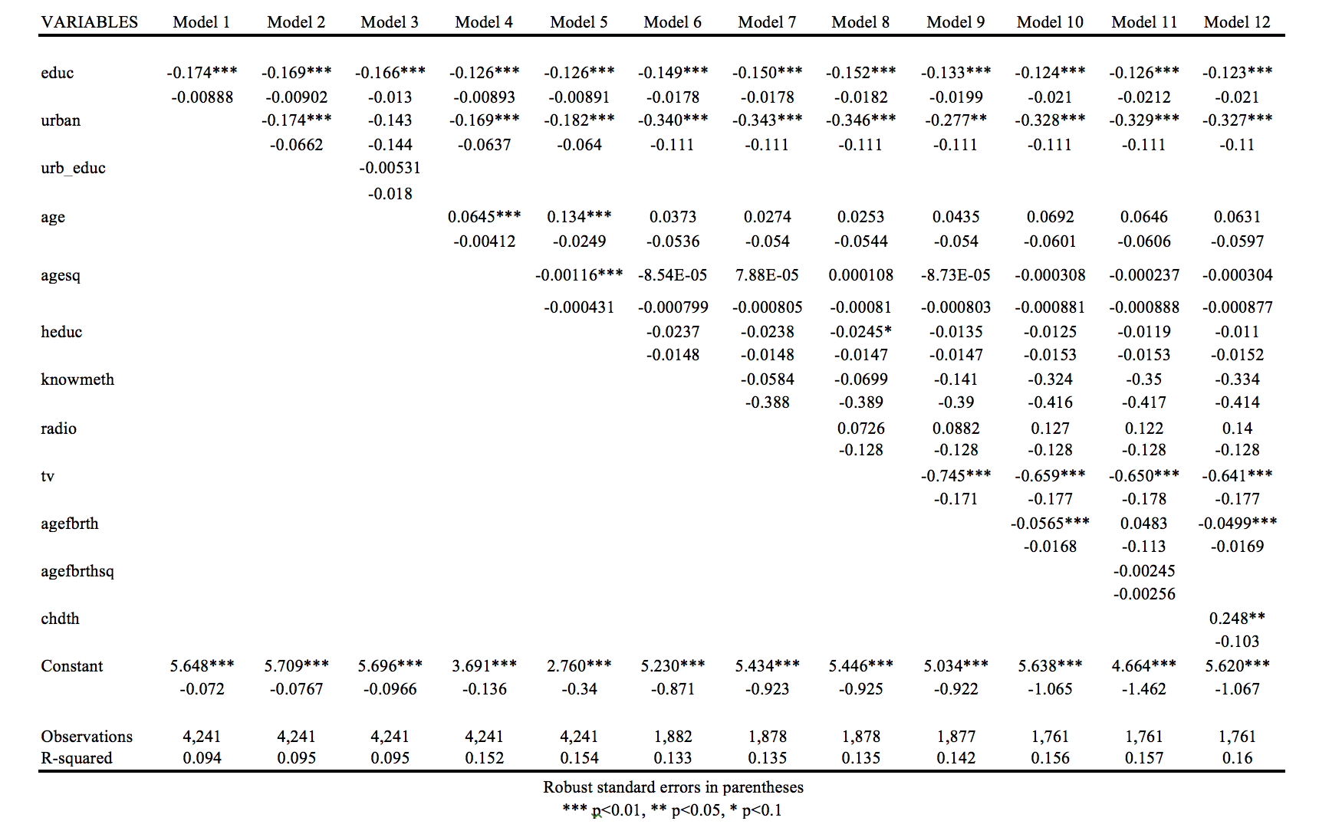

**Graph 1**

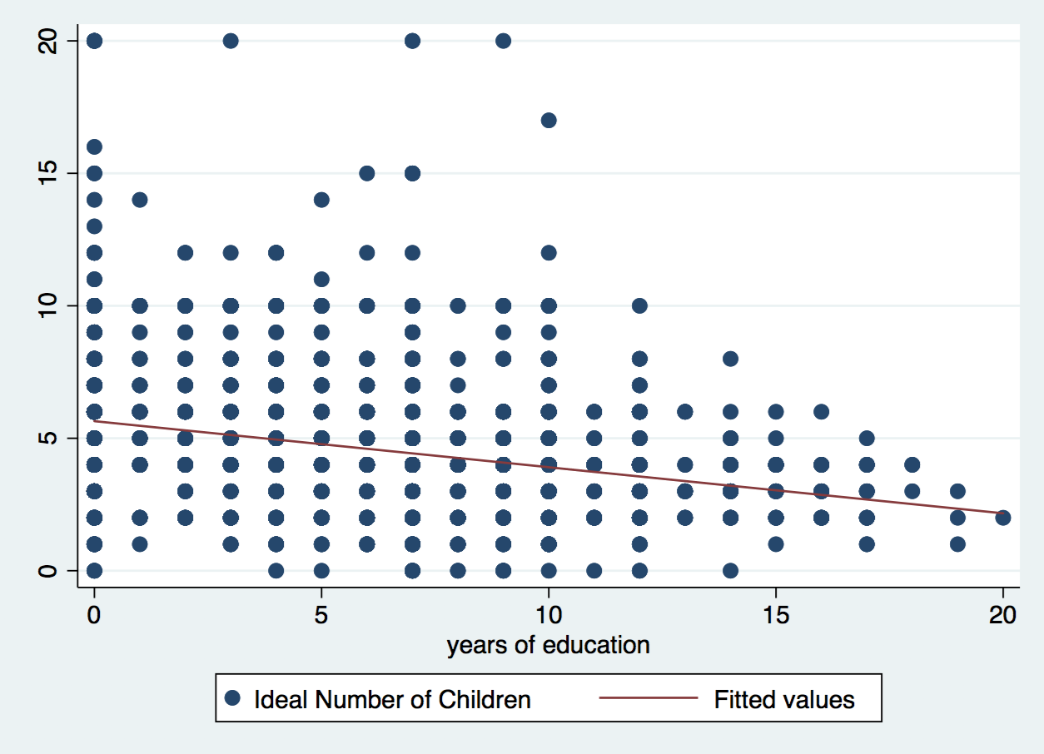

**Graph 2**

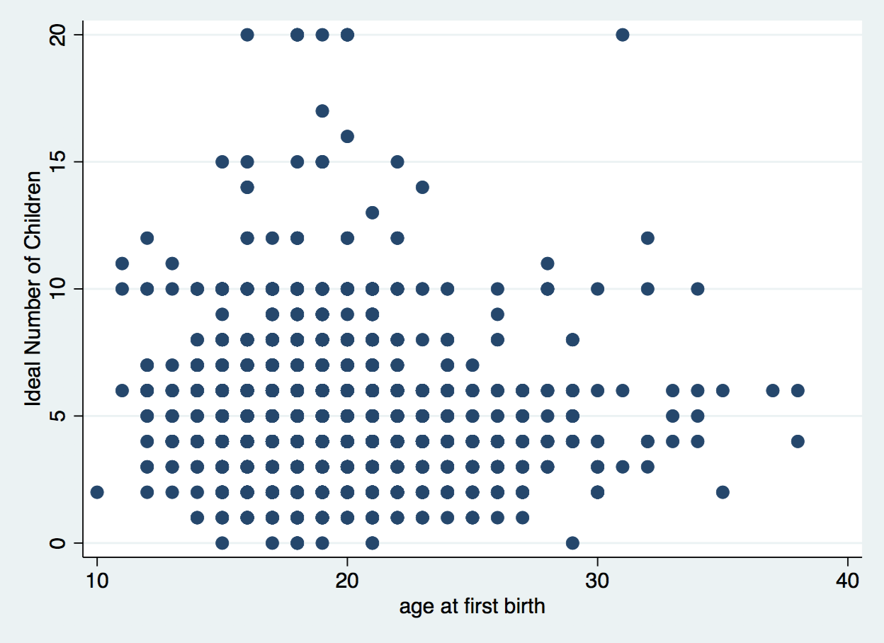

**Summary and conclusion**: Even after holding constant important socioeconomic factors, such as husband education, urbanization, age, access to mass media, and children death and controlling for relevant negative and positive o.v.b , the partial effect of years of education on ideal number of children remained negative and significant at the 1% level from the first until the last model, supporting our hypothesis and illustrating the power of education itself even in simple random sampling. Furthermore, the insignificance of knowmeth in all models and scenarios tested showed that other factors, besides contraceptional knowledge, are essential in order for family planning to have a meaningful impact on ideal number of children; for instance, by educating young women about reproduction and result in a better acceptance low-fertility menatlity and incorporation of family planning at a young age. Also, such insignificance makes sense, since the dependable variable is not number of children ever born (ceb), which would undoubtly be affected by knowmeth, but rather a more psychologically complex feature, which may be, and was, according to our final model, more succeptible to be influenced by variables, such as schooling, age at first birth, and children death, which remained significant until the end, instead of successful dissemination of family planning information.

By illuminating the persistently significant impact of years of schooling and insignificance of knowmeth, our research infers that policies of investment on primary education are essential, especially considering the continued 1% significance of age at first birth on the last model; nearly 50% of 19-year-olds were either pregnant or mothers (Rutenberg, Diamond,1993) , and because of that very few women attend school beyond their early twenties, justifying redirecting more funds from secondary education, which receives the highest investment (BFTU, 2007). Furthermore, this paper illustrates Mass medias, especially TV access’s, impressive significance throughout the regressions, suggesting a possible, powerful tool for the government to target ideal number of children and truly contribute to shift reproductive mentalities, for instance, by investing on broadcasting women epowerment and programs on children mortality, teenager pregnancy, and the importance of schooling. An even greater change would be achieved with the investment on tv broadcasting at rural areas, as the variable urban also remained significant at the 1% level until model 12.

**Limitations and Future Research**: In order to improve our research, we could introduce additional explanatory variables, such as parental education, income (in the log format), and woman’s labor participation, which can be causing negative, negative or positive, and negative omited variable bias respectively, in our model, since we do not have them controlled for. Furthermore, it would be interesting to incorporate data of past and subsequent surveys, such as

the 1984 and the 2007 Botswana Fmily Health Surveys into our data set. This way, we would be able to analyze how ideal number of children changed over time as well as its relationship with education and media outreach throughout the years. Additionally, by doing so, we would enjoy the analytical benefits of panel data, which is the best type of data when looking for causality effects.

**Appendices:**

**Work Cited:**

Basu, M.A. (2002). Why Does Education Lead to Lower Fertility?A Critical Review of Some Possibilities. *World Development,* 30(10), 1779-1790.

Gaisie, S.K. (1995). Fertility Transition in Botswana: An African Perspective. *S.Afr.J.Demography,*5(1), 35-47.

Martin, T.C. (1995). Women's Education and Fertility: Results from 26 Demographic and Health Surveys. *Studies in Family Planning*, 26(4), 187-202.

Rutenberg, N., Diamond, I. (1993). Fertility in Botswana: The Recent Decline and Future Prospects. *Demography,* 30(2), 143-157.

The Botswana Federation of Trade Unions (BFTU) (2007). POLICY ON EDUCATION IN BOTSWANA. 1-22.

Thomas, D., Muvandi, I.(1992). The Demographic Transition in Southern Africa: Another Look at the Evidence From Botswana and Zimbabwe. *Center Discussion Paper No. 668,* 1-26.

World Bank (2010). Fertility Decline in Botswana 1980–2006 A Case Study. 1-40.

Zaffiro, J.J. (1993). Mass Media, Politics and Society in Botswana: The 1990s and Beyond*. Africa Today*, 40(1), 7-25.

**DO FILE**

clear all

cd "/Users/fernandagutierrez/Desktop/stata project file"

use "/Users/fernandagutierrez/Desktop/stata project file/FERTIL2.DTA"

capture log close

log using stataprojectLog.log, replace

ssc install outreg2

ssc install estout, replace

gen agefbrthsq= agefbrth^2

gen chdth= ceb-children

eststo clear

eststo:estpost sum idlnchld educ urban urb_educ age agesq heduc knowmeth tv radio chdth agefbrth agefbrthsq ceb children

esttab using SummaryStats.doc, main(mean) aux(sd)

scatter idlnchld educ || lfit idlnchld educ

graph save Graph "/Users/fernandagutierrez/Desktop/stata fertility file/Graph.gph"

corr idlnchld educ urban urb_educ age agesq heduc knowmeth tv radio chdth agefbrth agefbrthsq

reg idlnchld educ,r

outreg2 using myreg.doc, replace ctitle(Model 1)

reg idlnchld educ urban,r

outreg2 using myreg.doc, append ctitle(Model 2)

reg idlnchld educ urban urb_educ,r

outreg2 using myreg.doc, append ctitle(Model 3)

reg idlnchld educ urban age,r

outreg2 using myreg.doc, append ctitle(Model 4)

reg idlnchld educ urban age agesq,r

outreg2 using myreg.doc, append ctitle(Model 5)

reg idlnchld educ urban age agesq heduc,r

outreg2 using myreg.doc, append ctitle(Model 6)

reg idlnchld educ urban age agesq heduc knowmeth,r

outreg2 using myreg.doc, append ctitle(Model 7)

reg idlnchld knowmeth,r

reg idlnchld knowmeth educ,r

reg idlnchld educ urban age agesq heduc knowmeth radio,r

outreg2 using myreg.doc, append ctitle(Model 8)

reg idlnchld educ urban age agesq heduc knowmeth radio tv,r

outreg2 using myreg.doc, append ctitle(Model 9)

test tv radio

reg idlnchld educ urban age agesq heduc knowmeth radio tv agefbrth,r

outreg2 using myreg.doc, append ctitle(Model 10)

scatter idlnchld agefbrth

graph save Graph "/Users/fernandagutierrez/Desktop/stata fertility file/Graph 2.gph"

reg idlnchld educ urban age agesq heduc knowmeth radio tv agefbrth agefbrthsq,r

outreg2 using myreg.doc, append ctitle(Model 11)

reg idlnchld educ urban age agesq heduc knowmeth radio tv agefbrth chdth,r

outreg2 using myreg.doc, append ctitle(Model 12)

log close